Title of abstract (times new roman 14 pt, bold, centred)

First Author,ª Second Author,ª Third Author^{b,}*
ªAuthor’s affiliation, City, Zip code, Country
^{b}Author’s affiliation, City, Zip code, Country
*Corresponding author: mainauthor@email.address

This is an abstract template for the 6th ISPCEM. Please directly use this template without changing the format and fit the abstract to 1 page of ISO A4 size (210 mm x 297 mm) paper, single-sided, with a top margin of 25 mm and side and bottom margins of 20 mm.
The title of the abstract is centre-aligned, with 14 pt bold Times New Roman font. Authors’ names are put below the title in 12 pt. Mark affiliations using superscripted letters (starting from a). Underline the presenting author’s name and asterisk (*) the corresponding author’s name. The affiliations and the contact information (e.g. email address) are italicised in 10 pt. The affiliations can include department and institution names, with city, zip code and country.
Main text is given in 11 pt. The length of the abstract is limited to 1 page including figures and tables. Captions of Tables and Figures are given in 9 pt with one line spacing from the text body (see below). All references¹ are indicated in 9 pt, with superscripted numerals (starting from 1) ascending in the order they appear in the text, and listed at the end of the abstract.

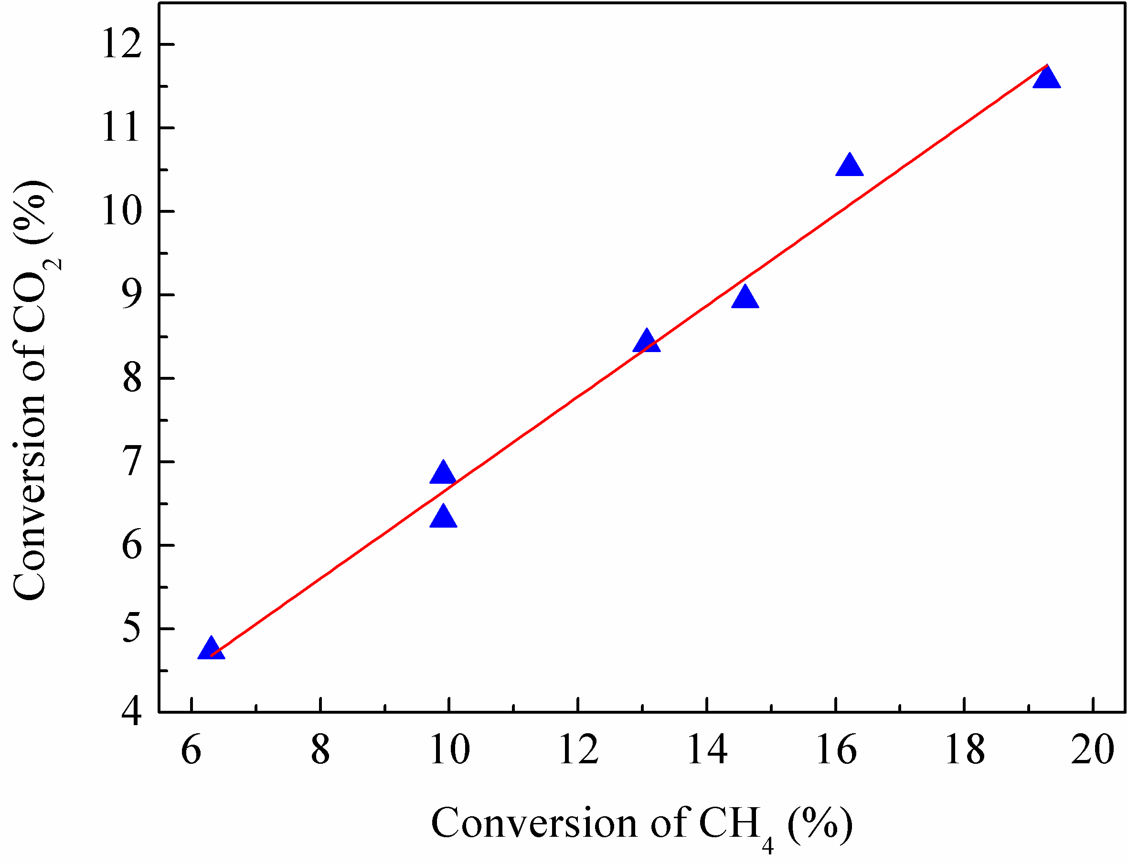

Figure 1. CO₂ conversion as a function of CH₄ conversion (CH₄/CO₂ = 3:7) (9 pt).

Table 1. Comparison of dry reforming energy efficiencies with different plasma sources (9 pt).
Plasma | Power (W) | Feed flow  (ml min⁻¹) | Conversion (%) |  | Selectivity (%) |  | E (mmol/kJ) | Ref
Plasma | Power (W) | Feed flow  (ml min⁻¹) | CH₄ | CO₂ | H₂ | CO | E (mmol/kJ) | Ref
DBD | 50 | 50 | 56.4 | 30.2 | 31 | 52.4 | 0.32 | [1]
Gliding Arc | 165 | 7500 | 13.1 | 8.4 | 31.4 | 69.5 | 3.1 | This work

Please send the abstract to registration@ispcem24.com as a Word file attachment with a clear indication of your preference for either poster or oral presentation.

References
1. A.B. Author, C.D. Author, E.F. Author, Appl. Catal. B: Environ. 125 (2012) 439-448.

